MALL OF AMERICA – Case Study

Vivek Agarwal

1. Is there a business value to the MOA in giving free Wi-Fi to its consumers? Justify your answer in no more than 500 words.

In today’s world of data being mentioned as comparable to Oil, it is a very good step from MOA to provide free Wi-Fi to its consumers. When consumers will use free Wi-Fi MOA will get data from consumers related to day of visit, the stores they visited, places they visited, duration spent at each level/area/shop, etc by accurate device location tracking gathering using Wi-Fi routers. Such kind of data can be used by Mall administration & Management to analyze the consumer behavior, movement trend and can take a call based on that to devise Strategies, identifying offers, etc.

Free Wi-Fi would be an incentive for people when it would come to choosing between similar malls. And, with increase in customers (assuming other factors like overall management of mall in terms of merchandise, food, etc. is decent) the amount of data gathered would become enormous. This would give huge advantage to Mall once they utilize it for data analysis, and strategy definition.

The data collect can generate interesting results that will likely help the Mall better connect with its visitors and, in all likelihood, improve outcomes for Mall owners / management.

Some of the apparent benefits to Mall Operations

* It will help the mall operations to plan for better security, staffing and know where exactly most of the people are in case of an catastrophe.
* The mall operations can look to repeat events that attracted crowd and follow foot traffic of the patrons more accurately than before. From the session update table it can be clearly seen that 3rd Floor south side had lot of session updates.
* Mall operations can plan for the increase in the foot falls, which is clearly evident from the visitors in the years 2015 & 2016
* Simply put, an overall improvement in mall operations.
* Mall management can see it as an opportunity to cluster and lease high foot fall areas and low foot fall areas accordingly

Benefits to Mall tenants

* Navigating through 4.2 M SqFt space is a challenge. Any user with a Google Android phone can locate the store of their choice, departments within large stores thus enabling them to spend more time in the stores than searching for it, which will improve revenue of its tenants.
* In the world of “clicks or bricks” it will help marketers to segment and position customers and create marketing plans based on the new data that is available
* Fewer MOA apps found more patrons than other MOA Apps. The mall tenants can get almost instant feedback about the performance of their apps.

Benefits to Mall visitors

* The customers will get a different experience, which is unique and inline with the demand of the growing digital customers.
* The customers can get personalized experiences, with loyal customers that could include surprise plans, pay back options, notifications of specific events based on customers past interest etc.

1. How to design a pilot study that serves as a proof‐of‐concept to show the business value of individual level Wi-Fi usage data? Where could this go in the future? Please limit your answer to 500 words.

The potential future direction could be

* How to convert shopping in the mall into an unique experience, by providing consistent user experience across the entire stretch of Mall of America, that is expected to have 5 MnSQFt space.
* How can this be promoted as a single biggest draw for Minnesotans during winters that are harsh?

Assumptions

* Individuals level Wi-Fi data is assumed as Wi-Fi data from unique device IDs

Proposed Proof-Of-Concept

* Use Cases – Business Value
  + Running a clustering on individual wi-fi data may help to answer some of the question outlined below which may help to increase footfalls in malls and create better value proposition for the customers as well as realized value per square foot in the mall by managing it efficiently.
    - Trending of consumer counts on each day
    - Prediction about number of customers on any given day
    - Most visited levels by the consumers. Can help in identifying correct Business Value is in rent optimization of various levels
    - Average duration when consumers stay in Mall
    - Knowing average consumer numbers during various months / hours of the day. Strategizing to get more footfalls during leaner periods eg. Offers during leaner periods / winter months. Mall operations can also run targeted campaigns to drive additional footfalls and hence improve sales.
    - Shopping trend of various customers so that those can be targeted
    - Clustering of customers so that they can be targeted differently for different marketing strategies
  + Arrange events that will increase foot falls during the day, as it is clearly evident from the data that during the week days the foot fall is less.
  + Clearly a Negative correlation can be seen between the duration of the usage and the number of distinct apps/sessions. This makes the case for digitally pushing customer specific digital content for better customer conversion using those apps.
  + From the data it is evident that people are connected to Wi-fi as they move to different sections. It could be people who are visiting the Mall from longer distances. There can be targeted digital content for customers who travel more sections.
  + Friday and Saturday are when the patrons are connected for longer duration. On Sunday’s it is less. Additional research can bring in more details and this can help mall operations plan their staff strength accordingly.
  + Consistency of customer experience in terms of mall operations and promotions offered by the individual stores.
* Additional insight generation
  + Run up a survey to more accurately identify features, events in the mall that is targeted by the specific customer cluster.

Such kind of analysis with repetitive outcome sharing can be a huge advantage to Mall to overcome competition by devising & implementation appropriate marketing strategies, promotions, etc.

In future, after doing deeper analysis, and collecting different kinds of data, the available data can be utilized to further personalize the marketing approach for individuals. To get people to mall & have them do required purchase is always one of primary goals of sales in Malls.

1. What kinds of use‐cases exist from the mining of Wi-Fi‐data? Please be very specific here. Do not enumerate all questions provided in the case on pages 6 and 7. Enumerate only those use cases that the data provided to you along with this case can support, and while doing so, clearly mention the connection between the data and the use cases. Please limit your answer to 1000 words.

Using the Wi-Fi data an analytics system can be built. For that system several use cases can be derived, some of which can be as listed below.

Target Users : Mall Management including Administration & Sales Team

Shop Owners (if Mall shares data or analysis with shop-owners)

Goal : Increase profit of Mall by increasing footfall & correct shop rentals

Better administration of the Mall

Use Cases :

* Clustering of customers based on their frequency of visiting the mall, so that they can be targeted differently for different marketing strategies
* What is average footfall in the mall on daily & weekly basis?
* Is there any seasonality in the consumer’s footfall?
* Which time of the day is most crowded?
  + This would help in having correct # of staff by shops, security team & other admin staff. Additional marketing can be planned in those hours to reach maximum people.
* What is approximate prediction about number of customers next week?
  + Generating a regression
* Which levels are most visited by the consumers and how store layout can improve customer experience?
  + From the moa_analytics data and doing a basic regression between day of the week and the levels/sections visited it can be concluded that patrons visit 2 – 3 levels and 7-8 sections. One consideration for Mall operations can be that they have similar themed stores close by which will improve customer experience. Eg: can be kids clothing, kids toys stores can be located contiguously.
* What is the average duration for which consumers stay in Mall?
* What are peak & off-peak hours of the day?
  + Strategizing to get more footfalls during leaner periods eg. Offers during leaner periods
  + What corners of the mall is most crowded?
* Strategizing which area of the mall can have higher rentals and better realizing per square foot value.
* From the frequency plot of the sections in moa_session_update.csv, it is very clear that the sections East, South, South East show highest connectivity to Wi_Fi data. Hence the mall operations can look to lease these spaces for high prices compared to NorthExt, where the patrons connectivity.

Some of the other observation based on the data is

* The median time observed per distinct ap is 377 seconds which is approximately 6 minutes and with a mean of 1578 seconds around 25 minutes. This explains the behaviour that people connect for a shorter duration for most of the time. Hence this can be utilized for an impulse driven experience while the patrons are at the mall, if the digital contents are well segmented and targeted.
* It can be clearly seen, that there are very limited / No session updates while they are at the food court areas. This indicates that patrons do not intend to be digitally active while they are having food. With additional research mall operations could look up to reducing digital content in this area.
* From the moa_reoccurrence.csv file it can be seen that there are multiple devices that have reconnected to the MOA Wi-Fi network more than once. Devices that connect on a daily basis could as well be found. Considering patrons who come for the purposes of shopping we can rule out devices with high reconnections. Assuming 1 - 5 being an optimal numbers, it can be assumed that there are patrons that repeat their visit to MOA. Hence there can be a loyalty program that can be developed by Mall Marketing department to reward these patrons, thus ensuring loyalty and repeat visit of the customers.

1. Run segmentation analysis to better understand the behavioral patterns of mall visitors based on when and where people touch the Wi-Fi access points.

**Data Preparation:**

We were interested in knowing which areas people visit the most in the mall.

1. Basic data analysis was performed to look at the data and understand how the data is segmented. On closer look, it is observed that data has been collected in two ways
   1. Time spent at different level and corners of the mall.
   2. Number of session and how many apps is connected at which corner of the mall.

We have chosen time attribute as we were interested in knowing time spent by people at different levels and corners of the mall.

1. We have chosen 12 data from the list of 108 variable like time_0_1", 'time_0', 'time_1','time_2', 'time_3','time_4' (others can be found on R-code file)
2. We have used hierarchal clustering methodology to identify number of clusters.

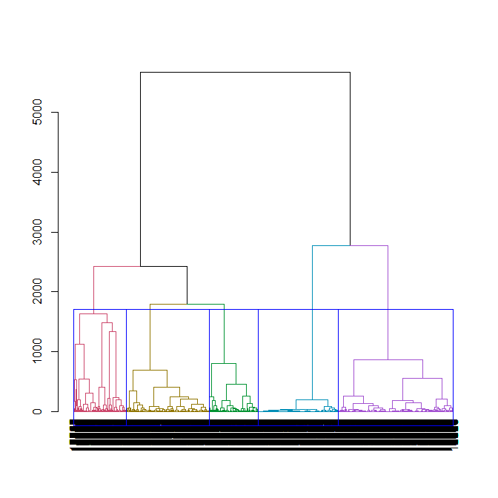

1. We have identified 5 numbers of clusters from the above dendrogram.

CLUSTER ANALYSIS

***Cluster Information:***

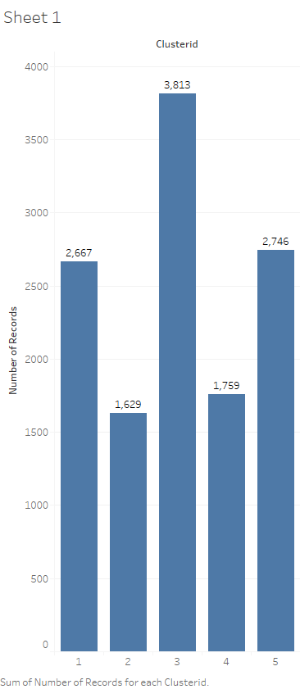

**Cluster Attributes:**

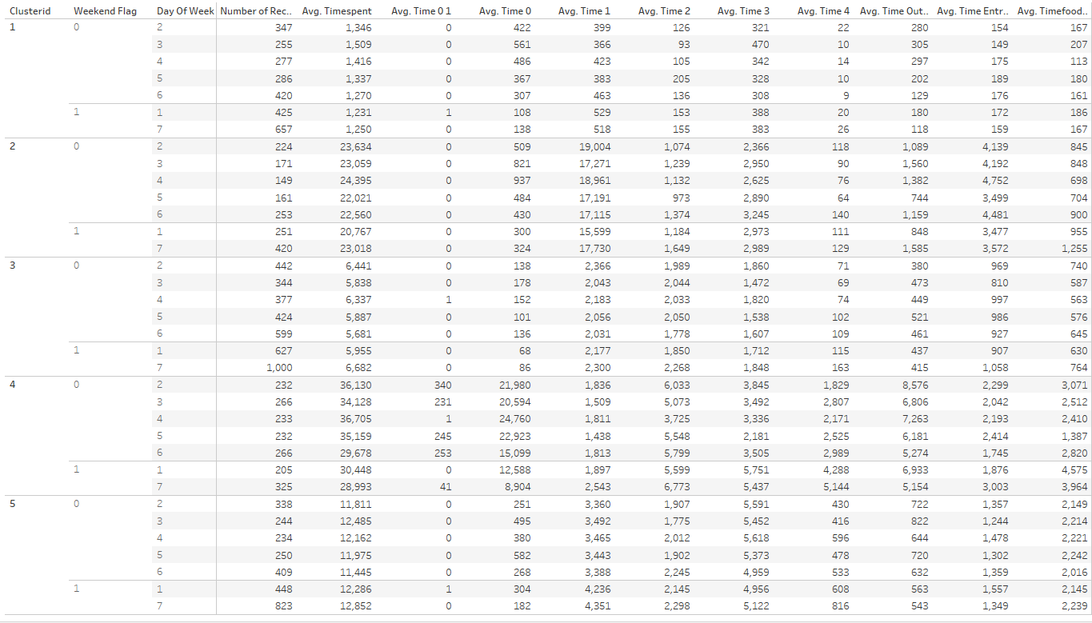

***Cluster definition:***

**Cluster 1: Short time patrons: -**average time spent of about 20 min **(These patrons may not be very digitally savvy)**

**Cluster 2: Casual Patrons with interest in other activity:**  average time spent of about 360 min who spend on most parts of the mall including outside except 4th floor

**Cluster 3: Patrons with specific purpose:** average time spent of about 100 min which is equally distributed across all floors

**Cluster 4: Weekday patrons:** average time of around 600 min which is equally distributed across all floors and sections. Patrons of this cluster are likely to be mall employee.

**Cluster 5: Casual Patrons interested in only shopping:** average time spent is about 200 min

**Is there a segment that does not peak on Saturdays or Sundays?** Cluster 2, doesn’t seem to be peak during weekends. These are patrons who enjoy other activity and love to be in the mall more on weekdays.

**What percentage of people belonging to a segment is likely to be mall employees?** Approx 13% are mall employees who are represented by cluster 4.

**At what times do entries and exits peak across these segments?**

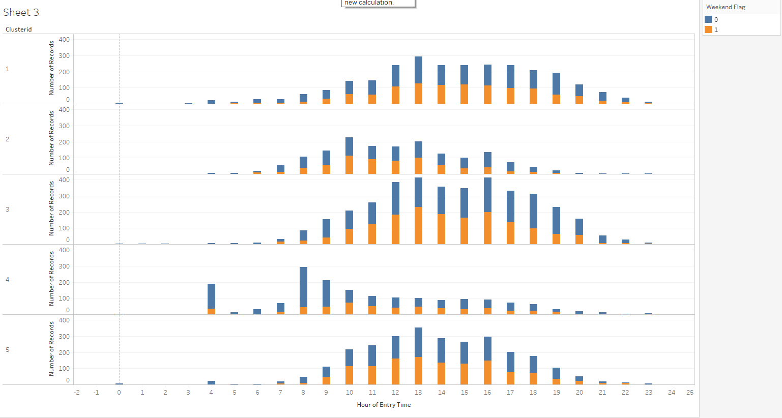

Entry Time for various Cluster

Exit Time for various Cluster

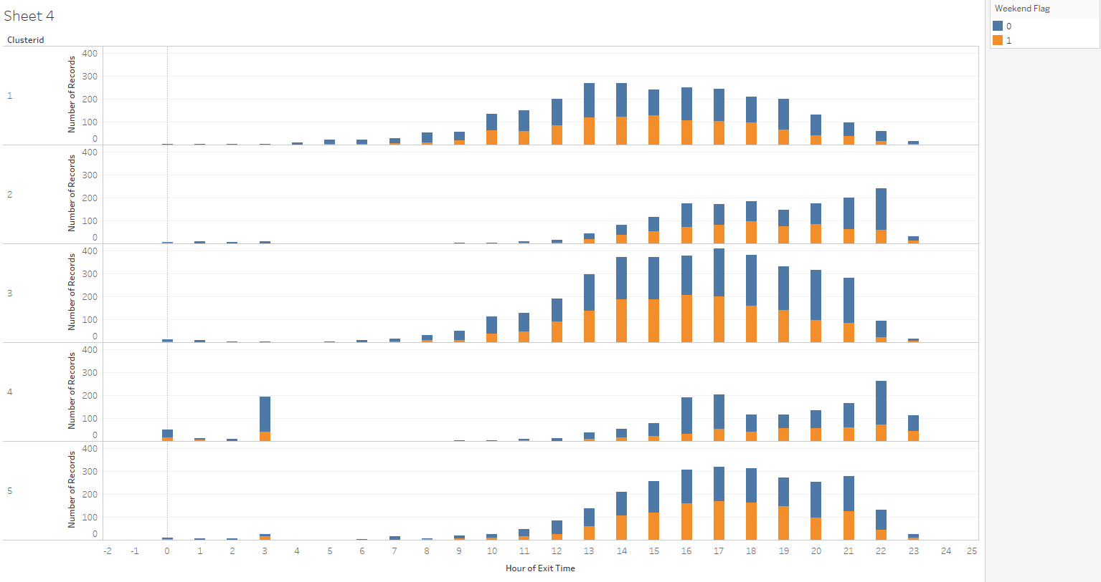

Cluster 1- Peaks around and Noon and stays until evening around 6 PM and typical exit is around 7 PM

Cluster 2 – Peaks around 10 AM and 1 PM and exist around 6PM – 10 PM

Cluster 3 – Both Entry and exist is consistent across the day but most visit during the day from 10 AM to 10PM.

Cluster 4 – Entry is from 8AM – 10 AM and exit around 5PM to 10PM.

Cluster 5 – Entry is from 10 AM – 4PM and exit 4PM – 9PM.

**Do any of these segments have a lot of quick visitors or a lot of long-duration visitors?** Cluster1, cluster 2 and cluster 5 represented such customers who spend minimum and maximum time.

Some of the use cases which can be answered by the clustering.

1. Cluster 2 people can be targeted for more fun and shopping as against cluster 5 people who are more shopping freak.
2. Cluster 2,3,5 patrons can be further mined to understand the location based on store layout to identify maximum time spends on which kind of store so that mall and store can run targeted campaign to increase in store purchase. for ex.

* Cluster 2: Patrons spend maximum time on 1E and floor 1 Level park area. More promotion can run in park to attract customers.
* Cluster 5: patrons spend maximum time on 3SW and 3S areas and hence targeted campaign can run with customer who spends maximum time in these areas

1. Mall administration team can look at providing differential rental value to different segment based on footfall in the area to help in generating more revenue per square foot.
2. Cluster has already provided frequency in each cluster as well as footfall per month. Clustering has also provided time when patrons are visiting the store and when it is peaking. Based on the clustering information, customer experience can be enhanced by targeted campaign / events during leaner period / time to increase footfalls. Some additional survey can be circulated and mined based on the clustering segments to understand liking and disliking for each cluster type (as we have device ID). The result can be utilized to run campaign during lean time.
3. As evident from the data, maximum occupation of mall can be seen during Saturdays and then Sunday and hence mall can be appropriately staffed during weekends. Custer 4 can be studied further to find number of employee in the mall during peaking time of other cluster and managed the operation more efficiently.